主标题：AC LED flexible strip, Flicker-free Ultrabright series

次标题：AC230V LED Strip light,SMD2835 120LEDs/m 13.5*6mm

- Product descriptions
- Super clear PVC extrusion make it looks very brilliant and more attractive,
- LM-80 approved LED of the premium quality with high brightness,
- Premium quality flexible PCB layer assure good heat dissipation, electrical safety and longer maximum length per input,
- Resistant against water, UV radiation, chemicals and abrasion.
- Safe and simple connection system for easy on-site installation after cutting
- Estimated lifetime L70 at Ta25 º C:＞40000h.

2. Product features
◆ 120°wide beam angle
◆ Available in homogeneous white tones,start from 2400K till 12000K
◆ a variety of light color come in red,blue,green,Pink,yellow etc
◆ longer connection length per input of up to 50m
◆ Premium light quality, offer CRI up to Ra90
◆ IP65 rated and for damp or wet locations use
◆ flicker-free driver is optional

3. Product Size
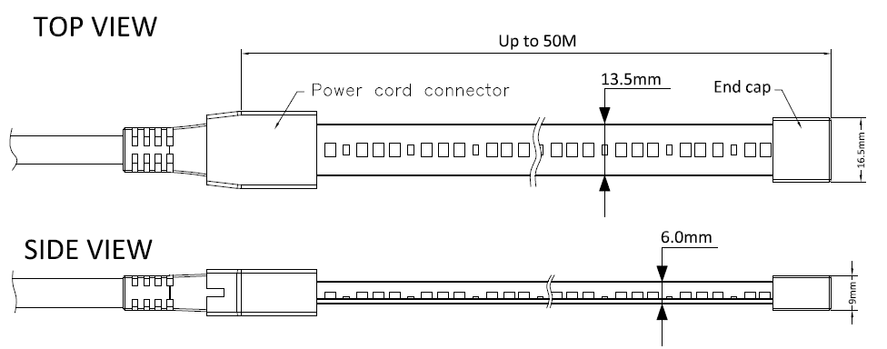

4. Product Technical data
LED Type: | SMD2835
LED Spec: | 24-26lm
LED Qty/m: | 120LEDs/m
Cutting intervals: | 1000mm
Overall size: | W(13.5mm)*H(6mm)
Input Voltage(V): | AC230V
Dimmable(Y/N): | N/A
Standard Driver type: | Flicker-free driver, IP65,PF≥0.5
Optional driver type: | Flicker-free driver,IP20,PF≥0.9
Length /Reel: | 25m/Reel,50m/Reel;
FPC board Spec: | 9.2mm wide
IP Rating: | IP65,IP67
Storage temperature: | -40 º C to +80 º C
Operating temperature: | -20 º C to +45 º C

- Product Spec sheet
Item no. | Input Voltage(V) | LED Qty/m | Typ.Light color | Typ.color temp. | Typ. power | Typ.Lumen/Meter | Typ.CRI | Cutting Intervals | Maximum run length
AH-W2835-120-27-## | AC230V | 120LEDs/m | warm white | 2700K | 8W/m | 540LM/M | 80+ | 1m | 50m
AH-W2835-120-30-## | AC230V | 120LEDs/m | warm white | 3000K | 8W/m | 566LM/M | 80+ | 1m | 50m
AH-W2835-120-40-## | AC230V | 120LEDs/m | Neutral white | 4000K | 8W/m | 650LM/M | 80+ | 1m | 50m
AH-W2835-120-65-## | AC230V | 120LEDs/m | Daylight white | 6500K | 8W/m | 680LM/M | 80+ | 1m | 50m
--The symbol ## represents the length of LED strips(Unit:m)
--due to unavoidable LED package, electrical component and other machine tolerances, normal input power and lumen tolerance(±10%）exist;

- Suitable Accessories

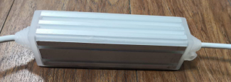
AC230V,400W,PF≥0.5,IP65

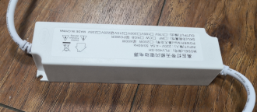
AC230V,350W,PF≥0.9,IP65

7. Installation type

