Ecoflex,SMD3528,GeneralLite series

- Product descriptions
- 12V or 24V,flexible LED strip with reflective, white surface and 3M adhesive tape on the back.
- Premium quality LED of the premium quality with high brightness, 120°beam angle.
- High amount of copper in FPC ensure excellent heat dissipation and Thermally enhanced tape ensures optimum heat transfer.

2. Product features
◆ 120°wide beam angle
◆ Available in homogeneous white tones,start from 1800K
◆ Most reliable SMD3528 LED package for excellent reliability
◆ only one bin per color for carefree handling and re-ordering
◆ Narrower color variance than ANSI standard
◆ Premium light quality, offer CRI up to Ra80
◆ Easy installation due to solder-free connectors optionally

3. IP Rating briefing

IP65 PU Surface Dripping

IP20,Naked

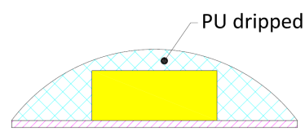
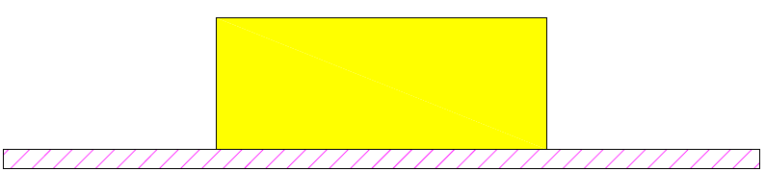

4. Product Technical data
LED Type: | SMD3528
LED Spec: | 6-8lm,
LED Chip brand: | Sanan, Epistar
CIE binning: | 1BIN
Regular SDCM: | SDCM≤5,
Regular CCT(K): | 2300K,2700K,3000K,4000K,6000K
CRI: | Ra80+
Input Voltage(V): | DC12V,DC24V
Driving mode: | Constant voltage
Dimmable(Y/N): | Y(Compatible with dimmable driver)
Max.run length(m): | 2.5m,5m,10m
Standard Length /Reel: | 5M/Reel
Flexible PCB Spec: | 8mm wide, 1OZ back copper layer
IP Rating: | IP20,IP65
Storage temperature: | -40 º C to +80 º C
Operating temperature: | -20 º C to +45 º C

- Product Spec sheet

LED Strip type | SDCM | Input Voltage (V) | LED Qty/M | Luminous flux/W( 400K) | Input Power/M | CRI | flexible PCB Spec |  | Maximum run length | IP Rating
 |  |  |  |  |  |  | W/mm | thickness
DC12V/24V SMD3528 LED Strip,CRI80+,IP20,LED Strips | ≤5Steps | 12V | 60LEDs | 380LM | 4.8W | 80+ | 8mm | 1 OZ | 5M | IP20
 |  | 24V | 60LEDs | 380LM | 4.8W | 80+ | 8mm | 1 OZ | 10M | IP20
 |  | 12V | 120LEDs | 650LM | 9.6W | 80+ | 8mm | 1 OZ | 5M | IP20
 |  | 24V | 120LEDs | 650LM | 9.6W | 80+ | 8mm | 1 OZ | 10M | IP20
DC12V/24V SMD3528 LED Strip,CRI80+,IP65,LED Strips | ≤5Steps | 12V | 60LEDs | 345LM | 4.8W | 80+ | 8mm | 1 OZ | 5M | IP65
 |  | 24V | 60LEDs | 345LM | 4.8W | 80+ | 8mm | 1 OZ | 10M | IP65
 |  | 12V | 120LEDs | 590LM | 9.6W | 80+ | 8mm | 1 OZ | 5M | IP65
 |  | 24V | 120LEDs | 590LM | 9.6W | 80+ | 8mm | 1 OZ | 10M | IP65

Notes:
--the typical lumen as shown in the table above per meter is related to 2700K, warmer light color such as 2400K,2100K is reduced and colder light color such as 3000K,4000K,6500K is increased.
--due to unavoidable LED package, electrical component and other machine tolerances, normal input power and lumen tolerance(±10%）exist;

